AJOU-SUWON
SCHOLARSHIP FOR MASTER’S DEGREE (ASSM)

AJOU UNIVERSITY
SOUTH KOREA

2022. 12

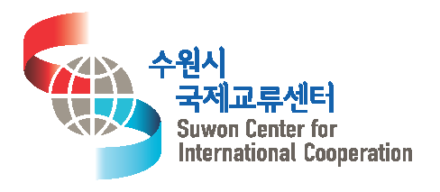
I Ajou-Suwon Scholarship for Master’s Degree (ASSM)
- BRIEF INTRODUCTION

In order to nurture talented students from sister cities of Suwon city, Ajou University and Suwon Center for International Cooperation (SWCIC) set up the scholarship fund to invite students of high-caliber. ASSM was established to financially support students to gain professional and systematic knowledge that will help them to play a key role in their home city’s development after graduation.
To accomplish better outputs, Ajou University and Suwon Center for International Cooperation (SWCIC) designed financial support with scholarship named “AJOU-SUWON SCHOLARSHIP FOR MASTER’S DEGREE(ASSM)”, which operates master’s degree courses in Ajou University’s Graduate School of International Studies in the fields of International Business, International Trade, Civil Society Studies, International Development and Cooperation.
In particular, this program is designed to strengthen the relationships between Suwon City, Korea and sister and friendship cities all over the world. Students, who have been given an opportunity to see Korea’s experience in poverty reduction and socio-economic development, may gain a deeper understanding of Korea and contribute to the future social, political and economic ties between the two nations.

List of Suwon’s sister and friendship cities – 18 cities from 14 countries
Sister City | Australia Townsville
 | Brazil Curitiba
 | Cambodia Siem Reap
 | China Jinan
 | Indonesia Bandung
 | Japan Asahikawa
 | Mexico Toluca
 | Morocco Fes
 | Romania Cluj-Napoca
 | Russia Nizhny Novgorod
 | Germany Freiburg
 | Turkiye Yalova
 | Vietnam Hai Duong
 | U.S.A. Phoenix
Friendship City | China Zhuhai
 | China Hangzhou
 | Japan Fukui
 | Taiwan Kaohsiung

- PROGRAM OVERVIEW
- Name of the course: AJOU-SUWON SCHOLARSHIP FOR MASTER’S DEGREE(ASSM)
- Duration: March 2nd, 2023 ~ February, 2025 (24 months)
- Training Institute: Graduate School of International Studies (GSIS), Ajou University (http://gsis.ajou.ac.kr)
- Language: English
- Degrees
Major (Department) | Degree
International Business | Master of Business Administration (MBA)
International Trade | Master of Arts in International Trade (MA)
International Development and Cooperation | Master of Arts in International Development and Cooperation (MA)
Civil Society Studies | Master of Arts in Social Studies(Civil Society) (MA)

- Eligibility
- Be a student who got the official recommendation from Suwon’s sister cities (18 cities of 14 countries) with a Bachelor’s Degree or higher. (Government Officials of the sister cities, and employees in state institutes or NGOs are preferred)
- Have sufficient command of both spoken & written English to take classes conducted entirely in English and to write academic reports and thesis in English
- Should have a positive attitude and a strong will to get adjusted in a multicultural environment and to understand hosting country’s culture while studying at Ajou
- Should have a good moral characteristic to endure student life on campus
- Be in good health, both physically and mentally, to undergo the program
* Pregnancy is regarded as a disqualifying condition for participating in this program.
* Having a Tuberculosis or any kind of contagious disease is regarded as a
disqualifying condition for participation in this program
* Health & Medical Clearance Form should be submitted
- Should Contribute to the development of relationship with Suwon City and the related field after returning from studying
- A person who is enrolling in Korean educational instate or a previous beneficiary of this scholarship cannot apply

- Responsibility
- Should participate in the orientation and quarterly meeting with SWCIC.
- Should participate in the SWCIC programs at least twice a year.
- Should submit an individual future plan and an action plan for promoting the relationship between your city and Suwon to SWCIC before graduation.
- Must return to your home country upon completion of the training program.
- Recommended to participate in meeting with the delegation from Suwon after your return to home country.
- ASSM(AJOU SUWON SCHOLARSHIP FOR MASTER’S DEGREE) Scheme
- BENEFITS OF ASSM Scholarship
- 100% Tuition Fee for 4 regular semesters
- 100% Dormitory Fee for 24 months (2 people shared room, New International Dormitory at Ajou University)
* For the expectant graduates, dormitory fee will be guaranteed until the date they will stay in Korea for graduation ceremony up to 24months
- Settlement Allowance 380,000KRW
- Amount of ASSM Scholarship
(USD 1=1,300KRW)
Scholarship Type | Amount of ASSM Scholarship |  | Reference
 | KRW | USD
Tuition | 20,616,000~  25,461,600 | 15,820~  19,540 | - 100 % tuition will be waived by ASSM.  - M.A.(IT/IDC) : 5,154,000KRW * 4 semesters  - M.A.(CS) : 6,365,400KRW * 4 semesters  - M.B.A.(IB) : 6,208,000KRW * 4 semesters  (If students cannot complete the graduation requirements within 4 semesters, they have to pay for the 5th semester’s tuition fee by themselves)
On-Campus Dormitory Fee | 8,144,000 | 6249 | - * 2 people-shared room at New International Dormitory(on-campus, built in 2015) of Ajou University will be offered for free by ASSM.(On-campus dormitory)  - Regular semester : 1,295,000KRW * 4 times  - Summer/Winter Vacation : 741,000KRW * 4times  * The scholarship for the On-campus dormitory (2 people shared room) can be provided only if they stay in on-campus dormitory. If students want to stay off-campus housing, the scholarship for On-campus Dormitory Fee cannot be supported.
Settlement Allowance | 380,000 | 292 | - Settlement Allowance 380,000KRW * 1 time
Total | 29,140,000~33,985,600 | 22,361  ~26,081

* Tuition and On-campus dormitory fee is based on Fall semester of 2022 and is subject to change.
- M.A.(IT/IDC) : International Trade, International Development and Cooperation
- M.A.(CS) : Civil Society Studies(Civil Society)
- M.B.A : International Business

- Cancellation of Scholarship
ASSM scholarship may be revoked if students fail to meet the ongoing eligibility requirements as specified cases below.
- When any document of the scholarship application has been found false
- When student has got the any kinds of disciplinary action from the university
- When student has violated the guidelines and regulations set by the university and SWCIC
- When student takes a semester off the university
- When Ajou university and SWCIC has approved of the cancellation of scholarship

II Introduction to Ajou University and Suwon City
1. Introduction to Ajou University
Ajou University was established in 1973 under the motto of "Asia's best university for the 21st century" and now became a leading research university with 10 colleges in Korea. Ajou University is located in Suwon, about 30km south of Seoul, and has approximately 14,000 students (9,000 undergraduate, 3,500 graduate, and 1,500 in other courses).

The strength of Ajou's academic programs and researches lies in Engineering, IT, BT, NT, Medical Science, Business and International Studies. Also, Ajou University is widely recognized for its innovative international programs and strong support system for international students. Over 200 collaborative partnership with universities in 58 different countries shows that Ajou University provides and supports wide range of international programs such as student and faculty exchanges, international summer school, Korean language program, etc. Through mentioned programs, Ajou University welcomes about 750 international students a year and provides various majors in English.

Ajou University’s name bears an ambition to become ‘the best university in Asia in the 21st century when Asia becomes the center of the world’. Since its foundation, Ajou has pursued the following three virtues as guiding principles:

“Respect for Humans”,
“Seeking Truth from Fact”, and
“One World, One Family.”
◉ Respect for Humans (In-gan-jon-jung)
In-gan-jon-jung has a meaning of ‘respect others’. It is the first principle that Ajou pursues through its research, education, and public service. It teaches us to connect ourselves to our neighborhoods, nation and to the world through respect and understanding. Also to not to see a human as a tool, but as an ultimate value.

◉ Seeking Truth from Fact (Sil-sa-gu-si)
Seeking truth from fact indicates that academic results are useful in practice. It is Ajou’s most fundamental philosophy that seeking truth and academic research must be based on facts and their results should contribute to people’s welfare.

◉ One World, One Family (Se-gye-il-ga)
This is a spirit that emphasizes that the entire world should move in harmony. We must break through the small barrier of the Korean Peninsula and advance to the world, and at the same time accept what’s coming from the outside. This is Ajou’s foremost principle in educating the youth.

1) Facts & Figures

A. Colleges & Schools
  - College of Engineering
  - College of Information Technology
  - College of Natural Sciences
  - School of Business Administration
  - College of Humanities
  - College of Social Sciences
  - College of Law
  - School of Medicine
  - College of Nursing
  - College of Pharmacy
  - College of General Education
  - Division of International Studies

B. Graduate Schools
  - General Graduate School
  - Graduate School of International Studies
  - Graduate School of Information and Communication
  - Graduate School of Engineering
  - Graduate School of Business Administration
  - Graduate School of Public Affairs
  - Graduate School of Education
  - Graduate School of Information & Communication Technology
  - Graduate School of Transportation & Intelligent Transport Systems
  - Graduate School of Public Health
  - Graduate School of Medicine
  - Graduate School of Law
  - Graduate School of Judicial Affairs
  - Graduate School of Clinical Dentistry
  - Graduate School of IT Convergence

C. Ajou Family
  - Students
Program | No. of Enrollment | No. of Total Student | Others
Undergraduate | 10,171 | 14,762
Graduate | 5,656 | 6,279
Total | 15,827 | 21,041

  - Faculties
Faculty | University | Hospital | Total
Full-time Faculty | 411 | 234 | 645
Special Faculty | 640 | 82 | 722
Total | 1,051 | 316 | 1,367

  - Staffs
Staff | University | Hospital | Total
Full-time Staff | 166 | 1,766 | 1,932
Contract Staff | 48 | 148 | 196
Total | 214 | 1,914 | 2,128

  - Partner Universities
Partner Universities and International Organizations | North America | 41
 | Europe | 118
 | Asia | 139
 | Oceania | 5
 | South America | 5
 | Africa | 9
 | Organization | 5
Total | 322 institutions in 65 Countries (Bilateral agreement)

D. Contact Information of Ajou University’s Graduate School of International Studies
Address: 206, World cup-ro, Yeongtong-gu, Suwon-si, Gyeonggi-do, Republic of Korea
- Website: http://gsis.ajou.ac.kr/ Email : gsis@ajou.ac.kr
  - Tel : +82-31-219-1551 / 3597 Fax : 031-219-1554

2. Introduction to Suwon City
1) About Suwon City
Suwon City which is located in southern central area of Gyeonggi Province (127°longitude, 37°latitude) has one of the largest self-governed cities in the country with a population of over 1.2 million and an area of 121.008㎢.
At the center of the city is Mount Paldalsan that stands 143 meters above sea level with the magnificent Mount Gwanggyosan to the North and Mount Chilbosan to the west surrounding the city and its plain to the south.
The annual average temperature is 13℃and average precipitation is 1,370mm which is the typical climate of the central region. The other typical characteristic of being in central region is that Suwon has very easy and fast transportation to access Seoul and other satellite cities in Korea.

2) History of Suwon
Suwon is an ancient city that has been known as the home of filial piety under name of Suseong or Hwasung. Relics from the Paleolithic Age found in the city’s Ji-dong and lui-dong District suggests that human settlement in this region begun as early as some 700,000 years ago. The name Suwon was first appeared in 1271 when Korea was divided into three Kingdoms. During that era, Suwon was named as Suwon Dohobu under Gorye Dynasty.

3) Suwon Hwaseong
The construction of Suwon Hwaseong Fortress began in the 18th year of King Jeonjo(1794) and was completed two years later in 1796. Suwon Hwaseong Fortress is considered as the greatest and most unique structure in the country’s history of fortresses. The Fortress was designed by Jeong Yak-yong and shows the science and art architecture of the 18th century. The uniqueness of this fortress is that it shows the building techniques of both East and West and used cranes, pulleys and potter’s wheels to build the fortress.
The Hwaseong Fortress is now a world famous tourist attraction and was named as a “Star of Korean Tourism” in 2012 and was selected as 50 places to to visit in South Korea by CNN.

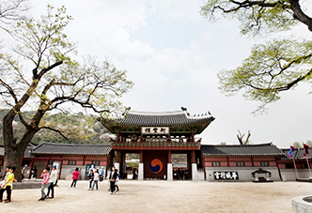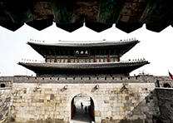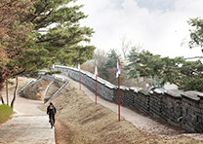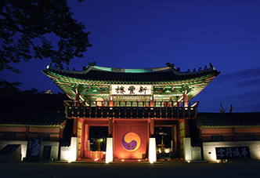

3. Introduction to Suwon Center for International Cooperation (SWCIC)
SWCIC is an organization established with aims to enhance Suwon’s international ties with various cities around the world including our own sister cities, as well as supporting our citizens to be equipped with global mind. Ultimately, SWCIC strives to achieve further development of Suwon.
Suwon has in total of 18 international sister or friendship cities in 14 different countries around the world. This makes us one of the most active municipal governments in Korea engaged in international community.
SWCIC provides various programs such as Foreign Language Club, Global Cultural Lectures, International Exchange Supporters Program, and other programs which will take place in a near future. Through these programs, SWCIC will contribute to promote the creation of a truly globalized community within Suwon. Especially, the Center aims to help globalization in private sectors, meeting demands from citizens, students, corporations and universities. At the same time, we will also devote ourselves to develop international programs that would reflect Suwon’s unique characteristics and enhance our City’s both tangible and intangible brand power.

III Departments and Curriculums

1. Department and Curriculum of Ajou GSIS

- International Business

Introduction
Globalization has created great challenges to companies and government organizations in the world. Managers now have to deal with diversity, integrating technologies, international marketing and sales campaigns and others in a rapidly changing global environment and economy. The purpose of the MBA in International Business is to provide a deep understanding of global issues faced by different types of organizations, and to enable participants to get a strong command of core business skills. For this purpose, International Business at AJOU GSIS provides prospective students a broad analytical perspective and theoretical and practical background in international business and market through offering required and elective courses.
Students who wish to pursue internationally oriented career in both private and public sectors that deals with international business and management are encouraged to study the International Business MBA at AJOU GSIS.

Course List of International Business
Courses for International Business  are as follows : |  | l | Supply Chain Management | l | Cross Cultural Management
 |  | l | Human Resources Management | l | Financial Derivatives
l | Business Statistics | l | Business Application Software | l | Leadership and Ethics Workshop 1,2
l | Economic Analysis I | l | Financial Statement Analysis | l | Korean Economy
l | Financial Accounting | l | International Trade | l | Korean Politics
l | Financial Management | l | Research Methods | l | Beginning Korean Language 1, 2
l | Organizational Behavior | l | Advanced Corporate Finance | * | The specific courses that any student takes  are individually chosen, in consultation with advisors, depending on each student’s  interests and course availability
l | International Business | l | Global Business Strategy
l | Marketing Management | l | Electronic Commerce
l | Operations Management | l | Marketing Research
l | Managerial Accounting | l | International Finance
l | International Capital Markets | l | International Economic Policies and Organizations

- International Trade

Introduction
International Trade studies the analysis of economic, political and social implications of exchange between traders in more than two national markets differs from that between traders within a national market. Also, International trade focuses on achieving better international cooperation and economic development. Trade relations among countries have evolved through collective debate, negotiations, agreements and on many, varied and complex issues. To strengthen the world economy for a sustainable development of trade, investment, employment and income growth, the need to develop and nurture human resources for such an economic task is indispensable. It is in this respect that AJOU GSIS has taken the cue to train experts and professionals for governments, public institutions, private companies and firms, or individuals, with a view to enhancing their skills and understanding in the field of international trade, to handle the intricacies, issues, and challenges of the world trading system for a better future.

Course List of International Trade
Courses for International Trade are as follows : |  | l | International Organizations
l | Statistics | l | Research Methods
l | Economic Analysis I | l | International Commercial Contracts and Dispute
l | International Trade | l | Settlements
l | International Finance | l | Electronic Commerce
l | International Economic Policies and Organizations | l | International Corporate Finance and Payment
l | International Relations | l | International Trade Practices
l | Leadership and Ethics Workshop 1,2 | l | Human Capital and Knowledge-Based Economy
l | Foreign Investment and Multinational Corporation | l | Korean History
l | Topical Seminar on International Trade and Finance | l | Contemporary Korean Society
l | International Political Economy | l | Korean Economy
l | Financial Derivatives | l | Korean Politics
l | International Business | l | Beginning Korean Language 1, 2
l | International Capital Market | * | The specific courses that any student takes are individually  chosen, in consultation with advisors, depending on each  student’s interests and course availability.
l | International Economic Law
l | NGO and Modern Society

- Civil Society Studies

Introduction
The Department of Civil Society Studies was established in 2021 by enlarging department of NGO Studies which had been established in 2000. The principal aim of the department of Civil Society Studies is to educate students about the issues related with civil society. “Civil society” is one of the most important concepts in the social sciences today and a key policy agenda among policymakers and practitioners. It refers to the collection of social organizations and groups which are distinct from, yet interact with, the government and the market. As many point out, apart from being a watchdog of government and business, a vibrant civil society is an important social partner for good governance.
Civil societies in the contemporary world encounter many difficult issues, including global pandemic, development, the aftermath of global financial crises, information technology revolutions, climate change, and questions related to democracy and human rights at local, national, and global levels. The study of civil society and its key players, civil society organizations, is at the forefront of multidisciplinary academic debates on complex and interconnected issues.
In the Civil Society Studies program, students learn about the relationships between academic debates and the everyday practices and policies of civil society and civil society organizations(CSOs). The Civil Society Studies program seeks to develop strong domestic and international networks that combine theory and practice. To achieve these goals, the Civil Society Studies program provides students with a wide variety of subjects, ranging from managerial skills for CSOs to cooperation among civil society, government, and international organizations for better governance.

Course List of Civil Society Studies

Courses for Civil Society Studies are as follows :
l | Research Methods in Social Sciences | l | Social Movements and Social Change
l | Quantitative Research Design  and Methods | l | Advanced Seminar on Current Issues in Civil Society
l | Introduction to Civil Society Organization | l | Civic Education
l | Civil Society Organization and Global Cooperation | l | Project and Business Development for Civil Society  Organization
l | Civil Society and the State | l | Development Project Management
l | Civil Society and Public Policy | l | Development Strategies and Analysis
l | Civil Society Organization and International Organization | l | Introduction to International Development  and Cooperation
l | Civil Society Organization and International Organization | l | Foundation of Development Policy
l | Political Economy of the State and International Affairs | l | Cross Cultural Management
 |  | l | International Relations and Peace
l | International Negotiations | l | Organizational Behavior
l | Financial Management of Civil Society Organization | l | Korea and World Economy :  Past, Present & Future  Korean Politics
l | Marketing and Funding for Civil Society Organization | I | Green Development
l | Human Resources Management and Volunteer Management of Civil Society Organization | I | Social Development and Poverty Reduction
l | ODA: Theory and Practice

- International Development and Cooperation
Introduction
Since this program combines international cooperation with development, it gives students an overview and deeper understanding of essential ideas and practices of International Development and Cooperation (IDC). Therefore, the program provides students a topical and thoughtful learning on the academic product of IDC. The program also provides students with political, economic, social and environmental perspectives of IDC through a multidisciplinary approach. Trying to incorporate objective viewpoints about governmental aid policies from developing countries in the South to developed countries in the North, it aims to explore a well-rounded view of developmental strategies as well as actors' behavior and precise issues of international cooperation.
The program is divided into three parts: (1) knowledge and information regarding the key motive power of IDC, Overseas Development Assistance (ODA) perspectives, (2) various IDC discourse such as development theories and their practical application cases, and (3) and exploration of contemporary politico-economic issues in the field of IDC. Finally, the program is designed for students seeking to work in national/international public agencies, NGOs, non-profit organizations, and governments dealing with IDC issues.

Course List of International Development Cooperation
Courses for International Development Cooperation are as follows : |  | l | NGO and Global Cooperation
 |  | l | International Political Economy
l | Research Methods | l | International Relations
l | Introduction to International Development and  Cooperation | l | International Organizations
l | ODA: Theory and Practice | l | Comparative Development Studies of the Emerging Markets
l | ODA Management and Evaluation | l | Cross Cultural Management
l | ODA of Korea | l | Organizational Behavior
l | Development Economics | l | Negotiation Skills
l | Development Project Management | l | Human Resources Management
l | Development Strategies and Analysis | l | Leadership and Ethics Workshop 1,2
l | Social Development and Poverty Reduction | l | Political Economy of the State and International Affairs
l | Green Development and Global Governance | l | Korean Economy
l | NGO Introduction | l | Korean Politics
l | NGO and International Organization | l | Beginning Korean Language 1,2

IV Academic Information
- aCADEMIC CALENDAR
Procedure | 2023 Spring Admission
Application Deadline | 23rd December, 2022
Selection for Scholarship Awardee | 16th~27th January, 2023
Admission package | 30th January~3rd February, 2023
Arrival in Korea | 22th February, 2023
Spring Semester Period | 2nd March, 2023 ~ Middle of June, 2023
Fall Semester Period | 1st September, 2023 ~ Middle of December, 2023
Graduation Ceremony | 21th February, 2025

- aPPLICATION DOCUMENTS AND SUPPLEMENTS
- [GSIS form] Application Form
- [GSIS form] Curriculum Vitae
- One photocopy of undergraduate diploma or Graduation Certificate
(Copied diploma should include an official stamp from the issuing University and
should be notarized from Korean Embassy or Apostilled)
- One photocopy of transcript of all undergraduate work
(Copied transcript should include an official stamp from the issuing University and should be notarized from Korean Embassy or Apostilled)
* Should also attach a grading system explanation of the bachelor degree granting
university on a separate paper)
- [GSIS form] Two letters of recommendation from professors or supervisors
- Recommendation Letter from the sister city of Suwon
- [GSIS form] Statement of Purpose (SOP)
- Official Test of English as a foreign Language (TOEFL) or International English
Language Testing System (IELTS) or its equivalence
- One copy of a Verification of Deposit (VOD) of the person responsible for student's
expenses (should have more than 4,000USD in the deposit)
- A Copy of passport
- Two passport-sized photos (plain background)
- [GSIS form] Health & Medical Clearance Form
- [GSIS form] Agreement Form for Academic Verification
- [GSIS form] Agreement on Privacy & Copyright Policy
- [GSIS form] Ajou-Suwon Scholarship Program Participants’ Responsibilities
- Degree Certificate (Chinese students only)
(Issued by Chinese Academic Degree & Graduation Education Development Center(www.cdgdc.edu.cn ))
3. hOW TO SCREEN
- Round 1: Evaluation of Application Materials (Document Review)
- Round 2: Evaluation of Applicants’ Academic English (spoken) and motivation to study, study plan and etc.

4. graduation requirements
- Officially enrolled for at least 4 regular semesters (2 years)
- Cumulative Grade Point Average: at least 3.0 out of 4.5
- Pass 2 subjects in Comprehensive Exam
- Thesis Defense(Optional) – Thesis / Non-thesis track can be chosen in the 3rd semester
- Credit Completion for each department

Major | Track | Credits from Class |  |  |  |  | Comprehensive  Exam | Thesis
 |  | Korean  Studies | Required | Elective | Research | Total
Int'l Business  (MBA) | Thesis Track | 3 | 18 | 15 | 6 | 42 | Two subjects,  during the 3rd semester or 4th semester | Thesis Track students  must  complete the thesis defense  before obtaining diploma
 | Non-Thesis Track | 3 | 18 | 21 | N/A | 42
Int’l Trade (MA) | Thesis Track | 3 | 15 | 15 | 6 | 39
 | Non-Thesis Track | 3 | 15 | 21 | N/A | 39
Civil Society Studies (MA), | Thesis Track | 3 | 12 | 18 | 6 | 39
 | Non-Thesis Track | 3 | 12 | 24 | N/A | 39
Int'l Development  and Cooperation(MA) | Thesis Track | 3 | 12 | 15 | 6 | 36
 | Non-Thesis Track | 3 | 12 | 21 | N/A | 36
(The above graduation requirement credits information for the 2021 Fall academic year is subject to change.)

- THESIS WRITING
When students want to write a thesis, students should apply for thesis advisor during the third semester and finish writing thesis proposal, and receive 3 research credits. Normally, students finish writing thesis during the fourth semester, go through thesis defense and receive another 3 research credits. Research credits are not given as letter grades such as A, B or F and these are given as “S” for Satisfactory when completing required works by the thesis advisor, “I” for Incomplete when not completing required works by the thesis advisor but can be changed to “S” in discussion with the thesis advisor, and lastly “U” for Unsatisfactory when not doing any works required by the thesis advisor and this cannot be revoked.

<Thesis Writing Process I>

Eligible to apply for the thesis track

- Thesis Workshop II
- Assignment of Thesis Advisor

- Thesis Proposal Development - Thesis Proposal Defense(allowed two times)
- Receive Research Credits
- Research Method Class(higher than B+) -- 3.5/4.5 (cumulative)
- Thesis Workshop I
- Receive Research Credits
- Thesis Track
- In the following semester, students go through Thesis Defense and receive Research Credits

<Thesis Writing Process II>
First 3 Research Credits can be obtained by working with the thesis advisor to develop your research idea into thesis proposal and pass thesis proposal defense

Second 3 Research Credits can be obtained by passing the thesis defense, and finally publishing your thesis during the 4th semester
“ S “ : Satisfactory
“ U “: Unsatisfactory
“ I “ : Incomplete
- Should receive “S” in both 3rd and 4th semester (2nd and 3rd for KOICA) in order to receive 6 research credits to complete graduation requirements.
- If you receive “U”, no credits will be given for the one semester research activities held.
- If you receive “I”, you should revise your work and obtain an approval from the thesis advisor to change your grade from “I” to “S”.
For preparing thesis during semesters, Office of Academic Information provides the group counseling and support related with Library E-journal and computer based matters.

- ACADEMIC SUPPORT AND CULTURAL EXPERIENCES
Category | Contents of Activity
Academic  Support | Special Lectures: We invite public figures in various fields to offer practical knowledge to students. During the lectures held two or three times on each semester, lecturers and students can freely exchange their knowledge, experience, opinion and so on.  <Example for the special lecture>  ● Korea in the World Economy: Past Achievements and Future Policy Options  ● Key Success Factors of Venture Business  ● ODA of Korea  ● Nuclear Power and Its Benefits and etc.  ● G20 Seoul Summit: A Korean Perspective  ● Korea's FTA  ● Groundswell in the current Web Environment, ETC
International Symposium: On every fall semester, student applicants have a chance to present their theses on a given topic. The applicants are supposed to be supervised by their advisors. At the symposium, progress-oriented discuss is followed by students’ presentations.
- Economic Democratization: Social Justice and Free Market Fairness
- Sustainable Development: Domestic, International and Transnational Issues
- The New Next Engines of Growth in the 21st Century: Innovating Social Systems
- Reimagining Borders? Securing Development in a Post-Sovereign Age
- Effective Governance and Institutional Reliability: Remapping Concepts, Policy and Geopolitics
- Deepening of Global Value Chain: Impact on Economic Development and Trade
- Making States Work in a World after Globalization
Cultural  Support | Field trips: For outdoor activities, we do not assign regular classes on Friday. Considering (most of) students' occupation as government employees, we seek practical knowledge and experience by hosting field trips to various companies.  International Day: On every fall festival, we host a culture exchange event for our students and foreign students. Approximately 500 foreign students in Ajou University and our students participate in this event and introduce their own culture to each other.  GAZETTE: We publish a student-oriented newsletter, Gazette, once a semester. Through Gazette, students can have some space to share their ideas on Korean culture and international issues and so on. We also send Gazette to GSIS alumni.
Support for  Exchange  With  Korean students | NUBI Ajou: ‘NUBI Ajou’ is the volunteering group of Korean students. It is one to one buddy program helps our students to get used to living in Korea. During semesters, there are various activities for our students to exchange with NUBI Ajou students and other foreign students in Ajou University.  ● Survival Korean Language, Ajou International Olympic  ● Korean Culture Experience

- GSIS Chairman & Office
- Professors’ Contact Information
Professor | Specialization | E-mail | Office
Kang, Mincheol | GSIS Dean | mckang@ajou.ac.kr | Rm#357-3 Yulgok Hall
Chang, Byeong Yun | International Business Chairman | bychang@ajou.ac.kr | Rm#420 Dasan Hall
Kim, Han Sung | International Trade Chairman | hkim1@ajou.ac.kr | Rm#405 Yulgok Hall
Kang, Shin Goo | Civil Society Studies Chairman | shingookang@ajou.ac.kr | Rm#507 Yulgok Hall
Jeong, Hyoung Wook | NGO/IDC Chairman | doist@yahoo.co.kr | Rm#373-1 Yulgok Hall
Jung, Yong Hun | ES Chairman | yonghun.jung@gmail.com | Rm#214 Energy Center

- GSIS Office’s Contact Information
Office | Name | Telephone | E-mail | Charge
GSIS | Chang, Byeong-Yun | 031-219-1550 | bychang@ajou.ac.kr | Dean of GSIS
GSIS | Ahn, Young-Sik | 031-219-1552 | ysahn@ajou.ac.kr | Program supervising
GSIS | Lee, Seunghee | 031-219-1551 | lshee@ajou.ac.kr | Admission, Academic Affairs
GSIS | Woo, Jihyun | 031-219-3597 | wjh1129@ajou.ac.kr | Ajou-Suwon Program and GKS program, Scholarship, Registration, Insurance, Grade
GSIS | Choi, Ji Woon | 031-219-3615 | gsis@ajou.ac.kr | Dissertation, Graduation, Thesis
GSIS | Cho, Eun-Hye | 031-219-1555 | gsis@ajou.ac.kr | Enrollment, Scholarship, Finance, KOICA Energy program
GSIS | Hwang, In-Jung | 031-219-3613 | gsis@ajou.ac.kr | New students, KOICA Civil Society Program
GSIS: Graduate School of International Studies

V Estimated Budgets
8. ESTIMATED BUDGET FOR 1 PERSON / SIX MONTHS
(usd 1 = 1,300krw)
Item | Ajou-Suwon Scholarship for Master’s Degree(ASSM) Covered/semester | ASSM Participants’ Payment | Others
Tuition | M.A.(IT/IDC) :  5,154,000 KRW | 0 | - 100% tuition will be waived by ASSM
 | M.A.(CS) :  6,365,400KRW | 0 | - 100% tuition will be waived by ASSM
 | M.B.A.: 6,208,000KRW | 0 | - 100% tuition will be waived by ASSM
On-Campus Dormitory | 1,295,000KRW | 0 | - * 2 people-shared room at New International Dormitory (on-campus, built in 2015) of Ajou University will be offered for free by ASSM.(On-campus dormitory)  - Regular semester: 1,295,000KRW * 4 times  - Summer/Winter Vacation:  741,000KRW * 4times  * The scholarship for the On-campus dormitory can be provided only if students stay in on-campus dormitory. If students want to stay off-campus housing, the scholarship for On-campus Dormitory Fee cannot be supported.
Settlement Allowance | 380,000KRW | 0 | - Settlement Allowance : 380,000KRW
Sum | 6,829,000KRW~  8,040,400KRW | Living Expenses +Admission Fee  +Insurance Fee | -

* Master of Business Administration : International Business
Master of Arts : M.A.(IT/IDC): International Trade, International Development and Cooperation
M.A.(CS): Civil Society Studies(Civil Society)

* Fees are based on Fall semester of 2022 and is subject to change.
* Living Expenses are not included in the estimated budget above.
* In the first semester, students have to pay for the Admission Fee Approx. 821USD (900,000KRW).

\
VI Life at Ajou University
- HOUSING
new International Dormitory (2 people shared room)
- ON-CAMPUS HOUSING AVAILABLE
- fACILITIES ON CAMPUS HOUSINg
(rOOM TYPE: 2 people shared ROOM)
* Recipients of Ajou-suwon scholarship for master’s degree (assm) are provided for
2 people shared room in new international dormitory only

<Room inside- 2 people shared room>
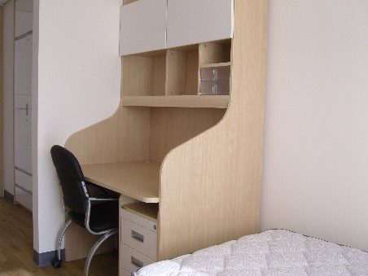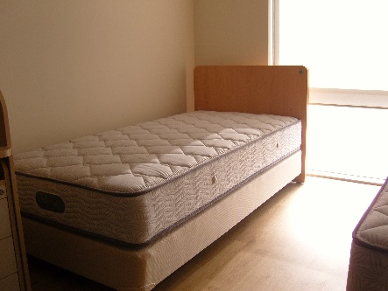
<Facilities- shared shower room, Coin Laundry Machine, Shared Kitchen>
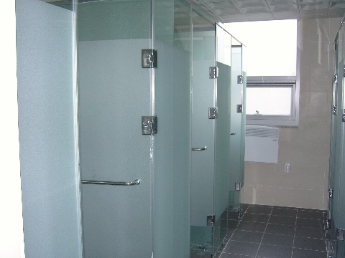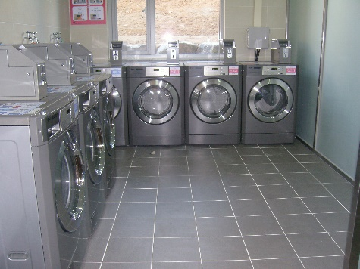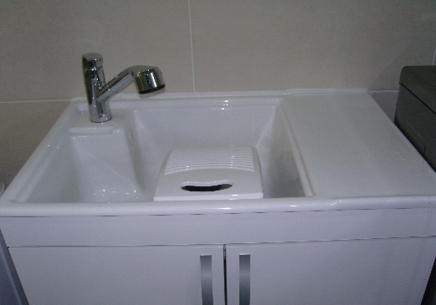
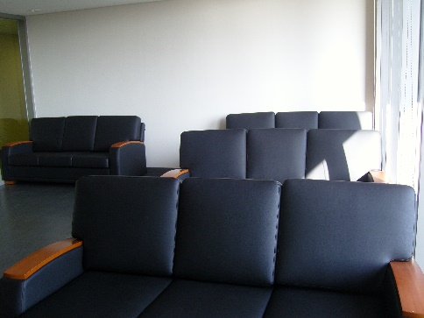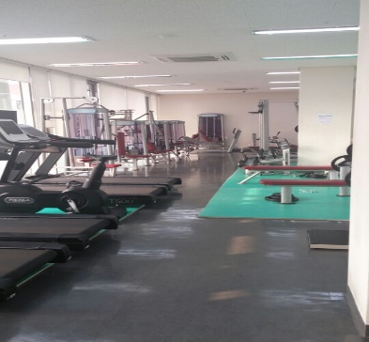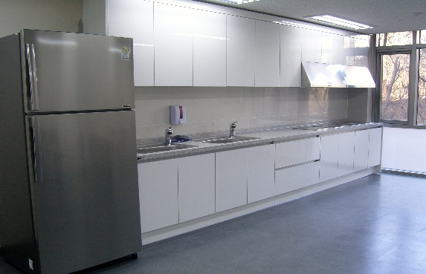

- OTHERS
Category | Contents
Support for Event/Living | ● During semesters, advisers and staffs support students in regarding of basic matters of living and events. Also, students can be helped by NUBI Ajou.
Support for VISA/Immigration | ● GSIS and OIA can help students with regard to basic information of VISA and immigration.
Medical Support | ● ‘Ajou Clinic’ located in the campus provides medicine of slight illnesses for free. Students can see doctors once a week in case of need.  ● For serious illnesses, students can be treated by ‘Ajou Foreign Clinic’ located nearby Ajou University campus.  ● (After March, 2021) Any foreigner who has stayed for six months or more in Korea is subject to the statutory subscription to the National Health Insurance Service(NHIS). The subscription of the health insurance will be automatically registered 6 months after your arrival to Korea.
Support for Certificates | ● Students can issue certificates by using automatic dispenser located inside of Ajou Supporting Center. There is a staff helping foreign students with regard to certificates.
Support for Room and Board | ● Students can cook by using the communal kitchen of the dormitory.  ● Students can have breakfast, lunch and dinner at school cafeterias. School Cafeterias have three options of western food, flour based food and Korean food.  ● Students can have more options by using nearby restaurants.
Support for Transportation | ● Students can use the school bus travelling back and forth between Ajou University and Suwon Station. During semesters, it travels every 30 minutes.  ● Student can use the school bus travelling back and forth between Ajou University and Sadang, Yangjae, Gangnam, Jamsil of Seoul and between Ajou University and Bundang of Gyeonggi-do. During semesters, it travels twice a day. (Morning and afternoon)  ● Airport bus regularly circulates between a hotel near the campus and Incheon International Airport (it takes about 1 hour).

